Cura Settings for Modified Anet A8 with 0.8mm nozzle  
Sep 6 2019

G-code snippets below

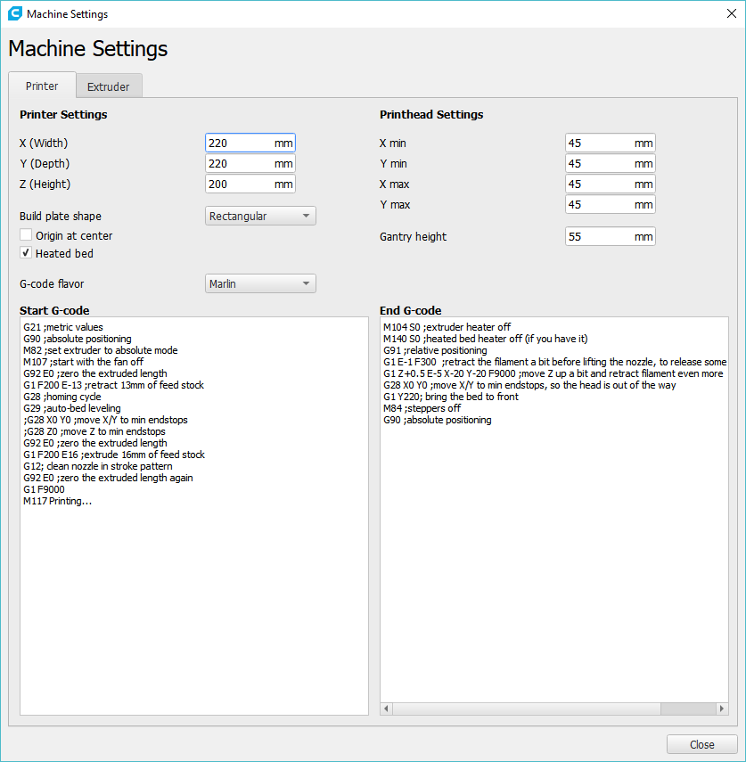

## Start G-code

**G21 ;metric values**

**G90 ;absolute positioning**

**M82 ;set extruder to absolute mode**

**M107 ;start with the fan off**

**G92 E0 ;zero the extruded length**

**G1 F200 E-13 ;retract 13mm of feed stock**

**G28 ;homing cycle**

**G29 ;auto-bed leveling**

**;G28 X0 Y0 ;move X/Y to min endstops**

**;G28 Z0 ;move Z to min endstops**

**G92 E0 ;zero the extruded length**

**G1 F200 E16 ;extrude 16mm of feed stock**

**G12; clean nozzle in stroke pattern**

**G92 E0 ;zero the extruded length again**

**G1 F9000**

**M117 Printing...**

## **End G-code**

M104 S0 ;extruder heater off

M140 S0 ;heated bed heater off (if you have it)

G91 ;relative positioning

G1 E-1 F300 ;retract the filament a bit before lifting the nozzle, to release some of the pressure

G1 Z+0.5 E-5 X-20 Y-20 F9000 ;move Z up a bit and retract filament even more

G28 X0 Y0 ;move X/Y to min endstops, so the head is out of the way

G1 Y220; bring the bed to front

M84 ;steppers off

G90 ;absolute positioning

